NEW CLOTHING FROM COSTCO:
Description: You will find in these pallets all kinds of clothing such as: Jackets, sweaters, blouses, pants, shirts, sportswear, flannel, polo shirts, jeans, pajama sets, underwear sets, socks, shorts, among others.
Brands: Tomy Hilfiger, Banana Republic, Adidas, Puma, Calvin Klein, Columbia, Nautica, Lucky Brand, Timberland, Levis, Speedo, Hurley, Jessica Simpsons, Skechers, Carter, Fila, Disney, Kirkland, Eddie Bauer, Andrew Marc, Buffalo, Spyder, Gerrys, Orvis, Gloria Vanderbil, Jacks New York, felina Lingerie, Carole Hochman, Andrew Marc, and Voyager, among others.
QUANTITY | DESCRIPTION | PRICE P/P | TOTAL  PRICE
200 | MIXED CLOTHING FOR WOMEN, MEN AND CHILDREN | $ 7,95 | $ 1,590
200 | WOMEN'S CLOTHING | $ 7,95 | $ 1,590
100 | MIXED CLOTHING FOR WOMEN, MEN AND CHILDREN | $ 8,45 | $ 845
100 | WOMEN'S CLOTHING | $ 8,45 | $ 845

“Keep in mind that we sell liquidation merchandise, so we cannot guarantee that in the pallets we offer you will find all the brands described or the specific quantity of each of them, as well as the specific type of clothing they contain and sizes. Keep in mind that as they are liquidation merchandise, the pallets may contain an undetermined percentage of pieces that show signs of having been used”
These descriptions are made in order to provide customers with the most information and accuracy about the conditions of the merchandise we sell.
It is important that you take into account that the clothes that come in sets or packages such as underwear, socks, flannels, pajamas, etc., regardless of whether they come in 2, 4, 6, 8, 10, 12 pieces, etc., are counted like 1 piece.
IF YOU REQUIRE MORE INFORMATION, PLEASE DO NOT HESITATE TO CONTACT US DIRECTLY VIA PHONE, WHATSAPP, EMAIL OR THROUGH OUR SOCIAL MEDIA NETWORKS. WE WILL BE HAPPY TO ASSIST YOU AND WE ARE HERE TO HELP YOU THROUGHOUT THE PURCHASE PROCESS

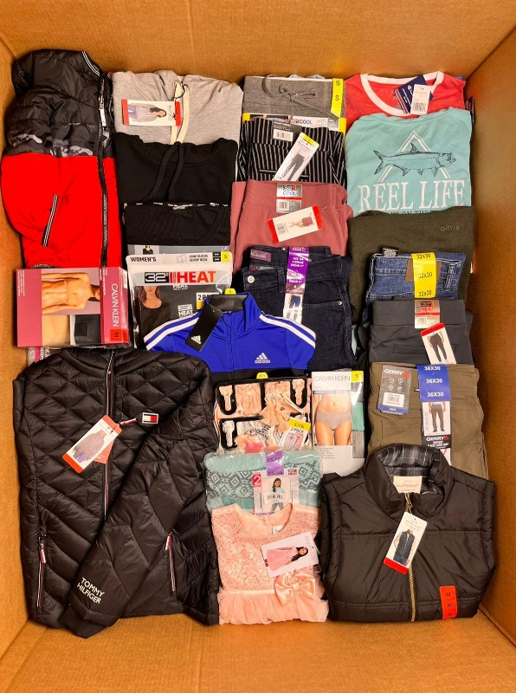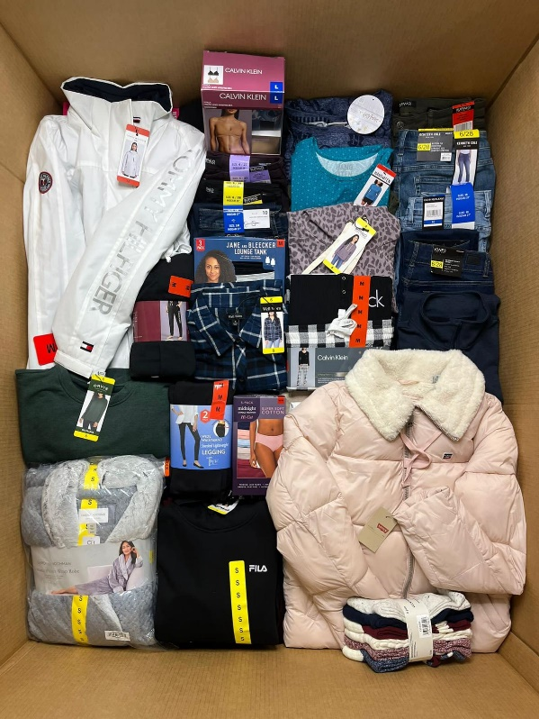
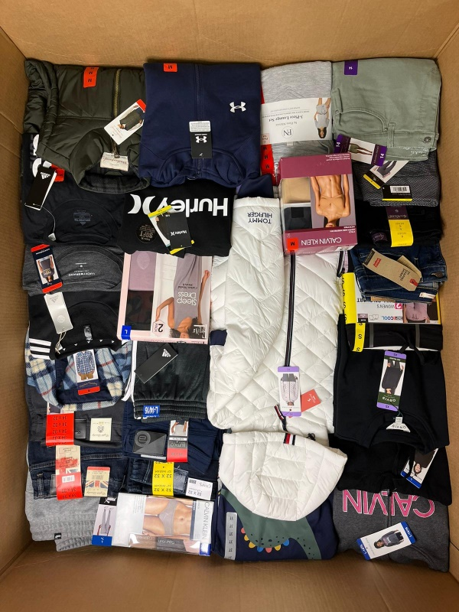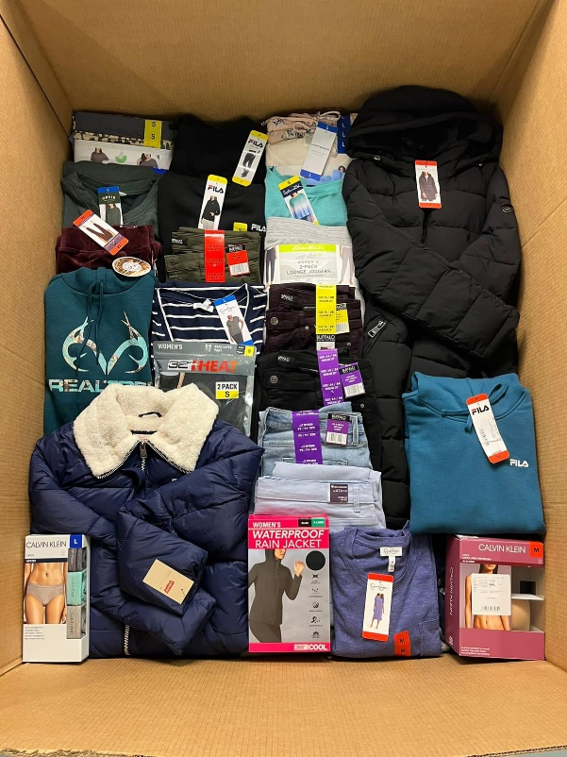

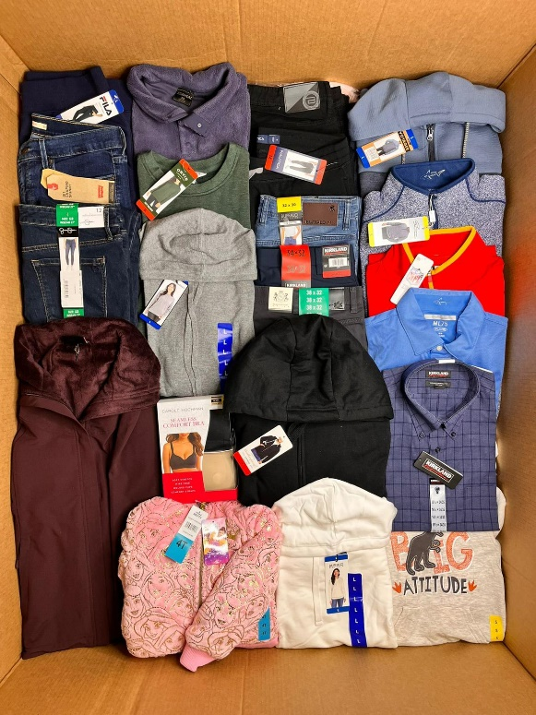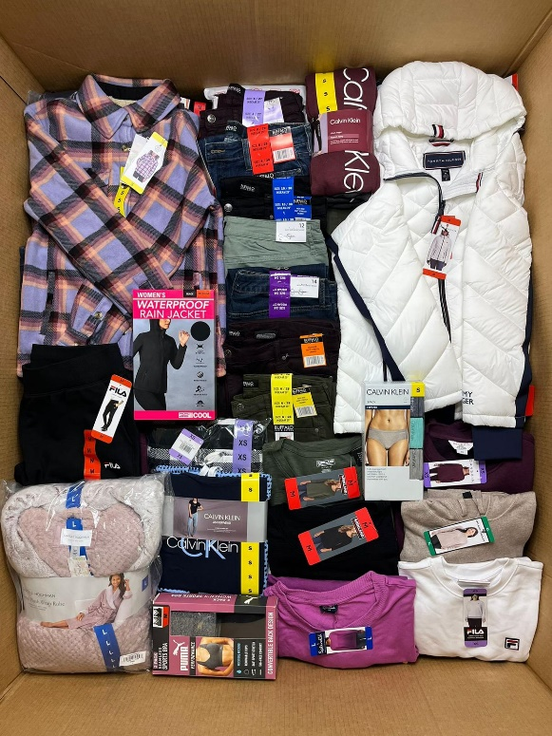
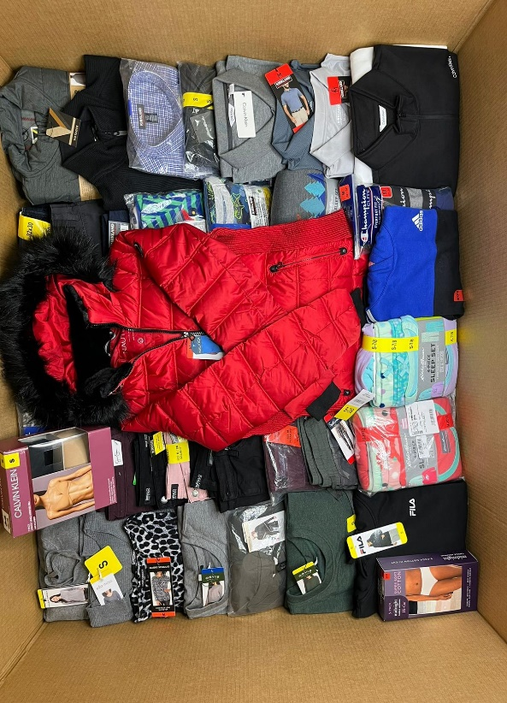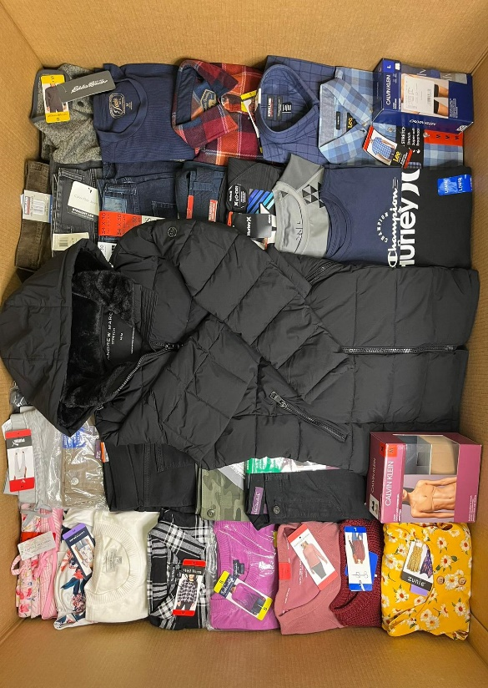

NEW CLOTHING FROM TARGET:
Description: You will find in these pallets all kinds of clothing such as: blouses, sweaters, pants, shirts, sportswear, flannels, polo shirts, jeans, pajama sets, underwear sets, socks, shorts, among others.

QUANTITY | DESCRIPTION | PRICE P/P | TOTAL  PRICE
250 | MIXED CLOTHING FOR WOMEN, MEN AND CHILDREN | $ 2,96 | $ 740
250 | WOMEN'S CLOTHING | $ 2,96 | $ 740
250 | CHILDREN’S CLOTHING | $ 2,96 | $ 740
300 | WOMEN’S BATHING SUITS | $ 2,96 | $ 888

“Keep in mind that we sell liquidation merchandise, so we cannot guarantee that in the pallets we offer you will find all the brands described or the specific quantity of each of them, as well as the specific type of clothing they contain and sizes. Keep in mind that as they are liquidation merchandise, the pallets may contain an undetermined percentage of pieces that show signs of having been used”
These descriptions are made in order to provide customers with the most information and accuracy about the conditions of the merchandise we sell.
It is important that you take into account that the clothes that come in sets or packages such as underwear, socks, flannels, pajamas, etc., regardless of whether they come in 2, 4, 6, 8, 10, 12 pieces, etc., are counted like 1 piece.
IF YOU REQUIRE MORE INFORMATION, PLEASE DO NOT HESITATE TO CONTACT US DIRECTLY VIA PHONE, WHATSAPP, EMAIL OR THROUGH OUR SOCIAL MEDIA NETWORKS. WE WILL BE HAPPY TO ASSIST YOU AND WE ARE HERE TO HELP YOU THROUGHOUT THE PURCHASE PROCESS

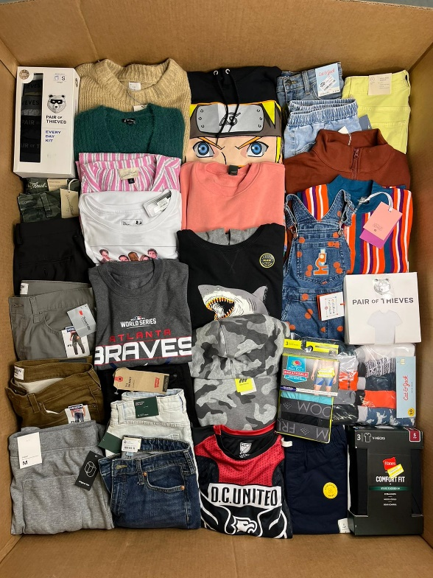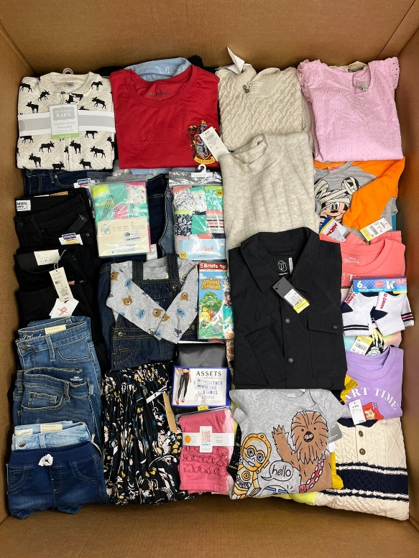
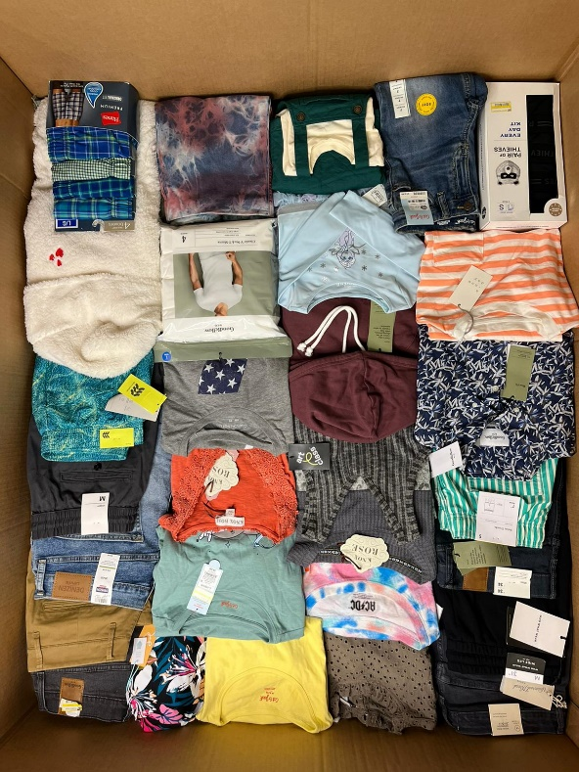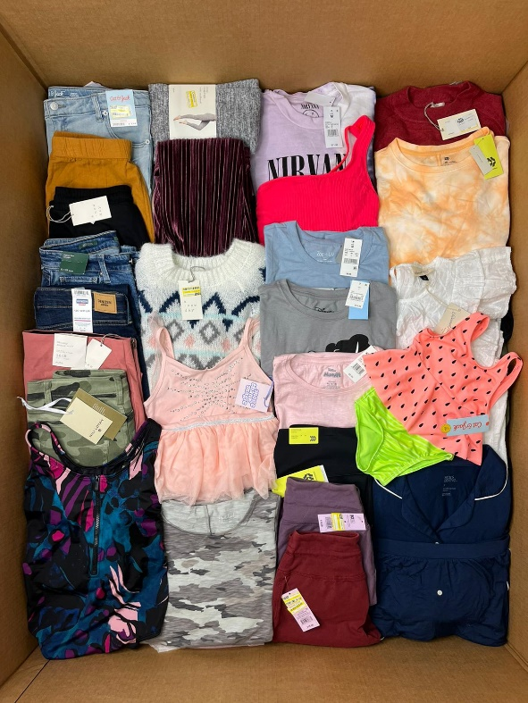

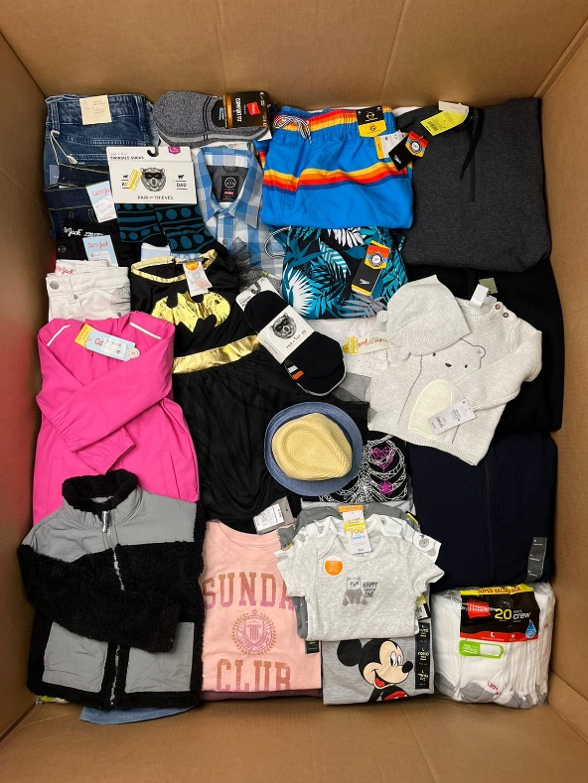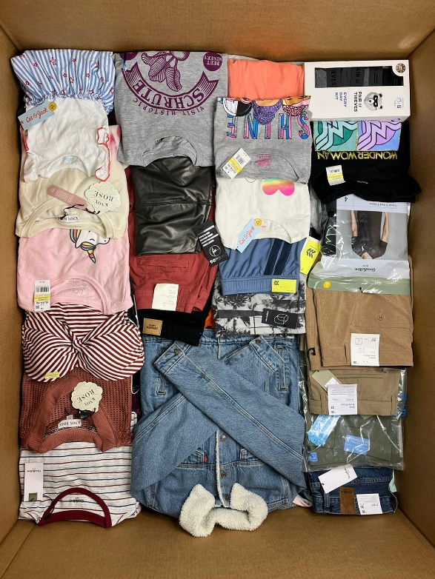
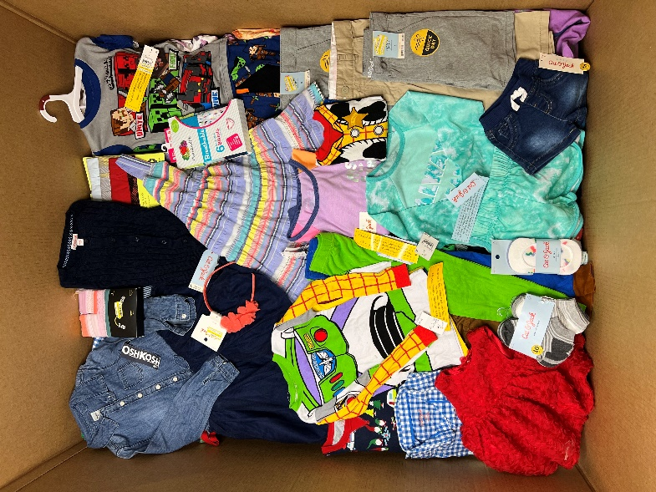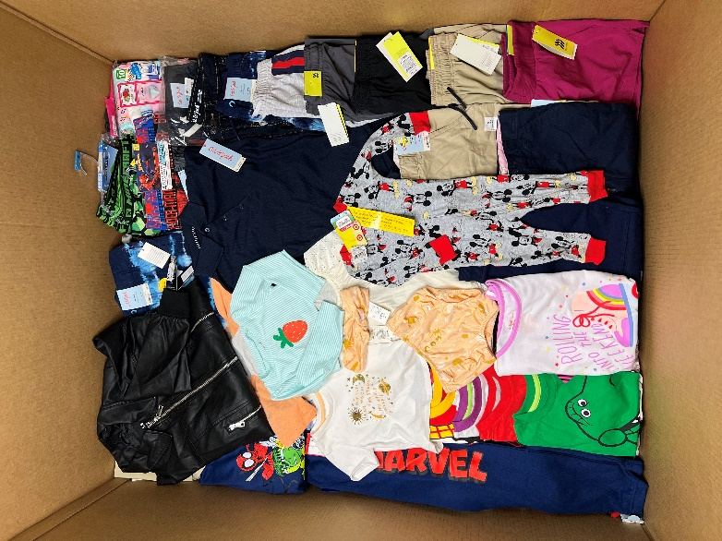

NEW SHOES AND CLOTHING FROM AMAZON:
Description: You will find in these pallets all kinds of clothing such as: blouses, sweaters, pants, shirts, sportswear, flannels, polo shirts, jeans, pajama sets, underwear sets, socks, shorts, among others, and in shoes you can find of all kinds such as sports, dress, sandals, boots, t-shirts, all for both women and men and children.

Brands: You will be able to find more private brands and less recognized brands.

QUANTITY | DESCRIPTION | PRICE P/P | TOTAL  PRICE
250 | MIXED CLOTHING FOR WOMEN, MEN AND CHILDREN | $ 2,96 | $ 740
250 | WOMEN'S CLOTHING | $ 2,96 | $ 740
100 | MIXED SHOES FOR WOMEN, MEN AND CHILDREN | $ 6,95 | $ 695

“Keep in mind that we sell liquidation merchandise, so we cannot guarantee that in the pallets we offer you will find all the brands described or the specific quantity of each of them, as well as the specific type of clothing they contain and sizes. Keep in mind that as they are liquidation merchandise, the pallets may contain an undetermined percentage of pieces that show signs of having been used”
These descriptions are made in order to provide customers with the most information and accuracy about the conditions of the merchandise we sell.
It is important that you take into account that the clothes that come in sets or packages such as underwear, socks, flannels, pajamas, etc., regardless of whether they come in 2, 4, 6, 8, 10, 12 pieces, etc., are counted like 1 piece.
IF YOU REQUIRE MORE INFORMATION, PLEASE DO NOT HESITATE TO CONTACT US DIRECTLY VIA PHONE, WHATSAPP, EMAIL OR THROUGH OUR SOCIAL MEDIA NETWORKS. WE WILL BE HAPPY TO ASSIST YOU AND WE ARE HERE TO HELP YOU THROUGHOUT THE PURCHASE PROCESS

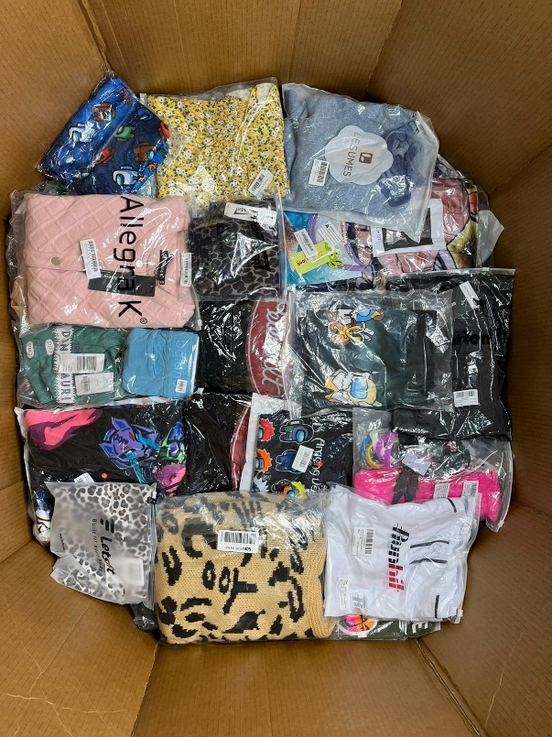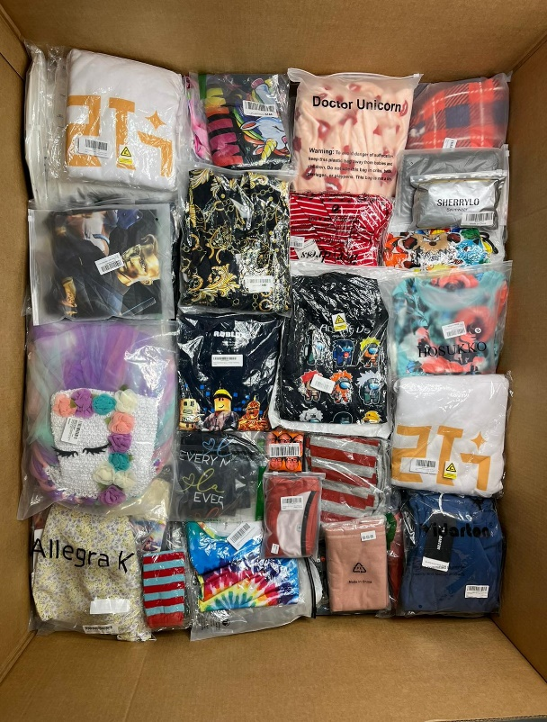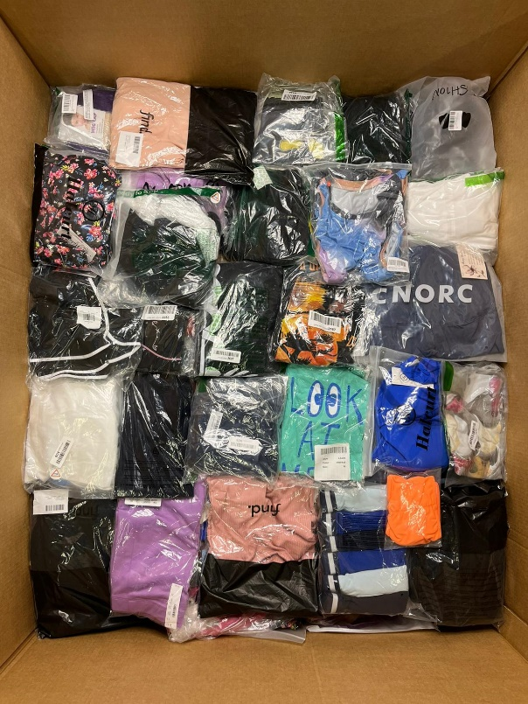

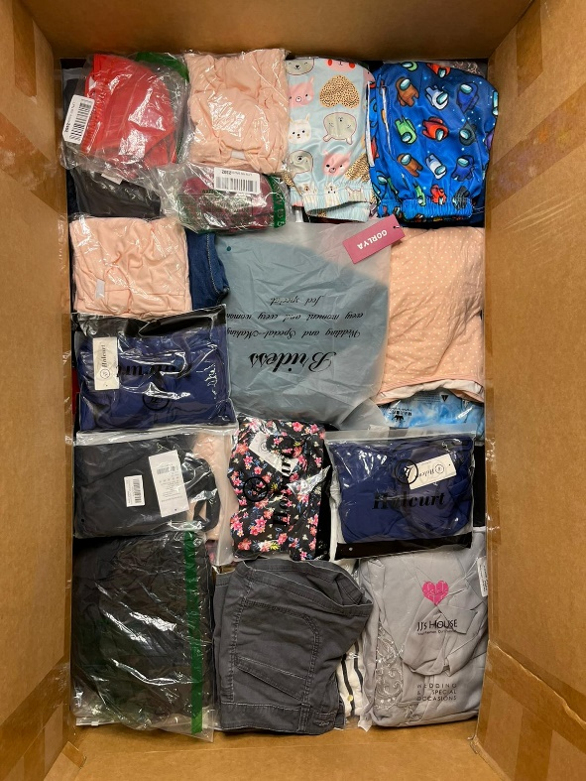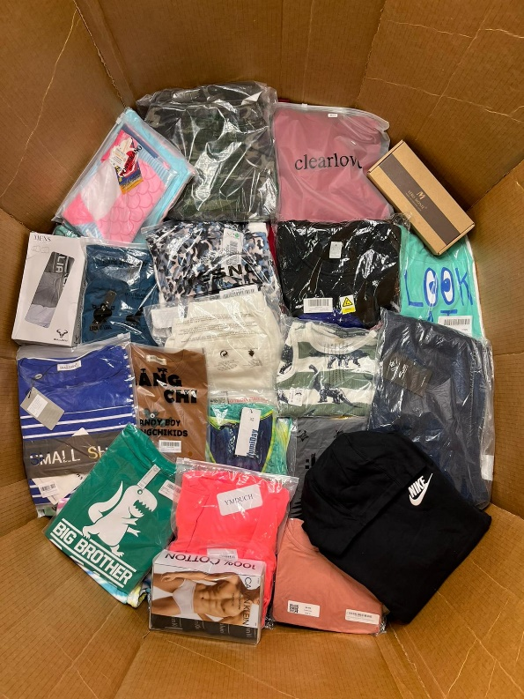
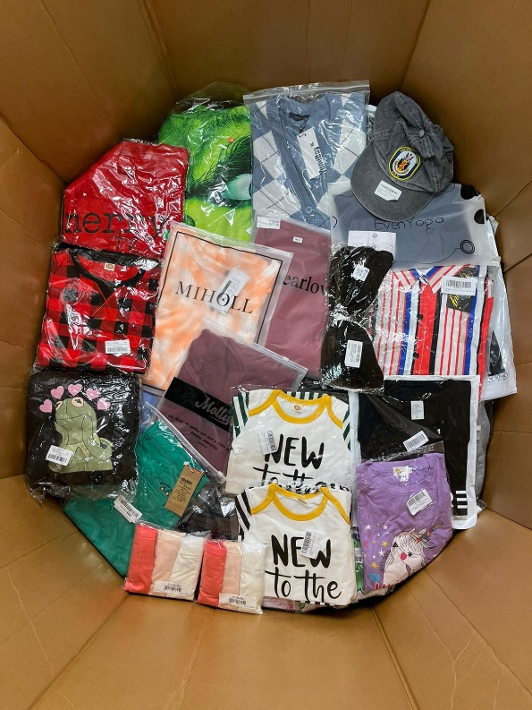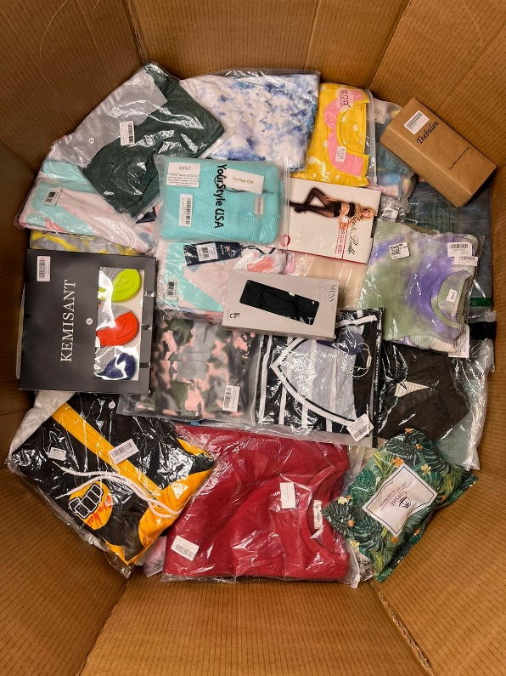

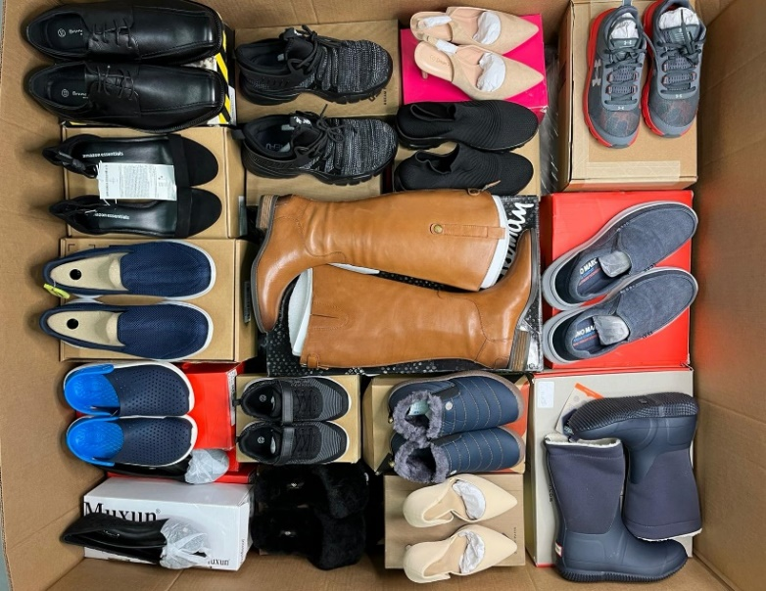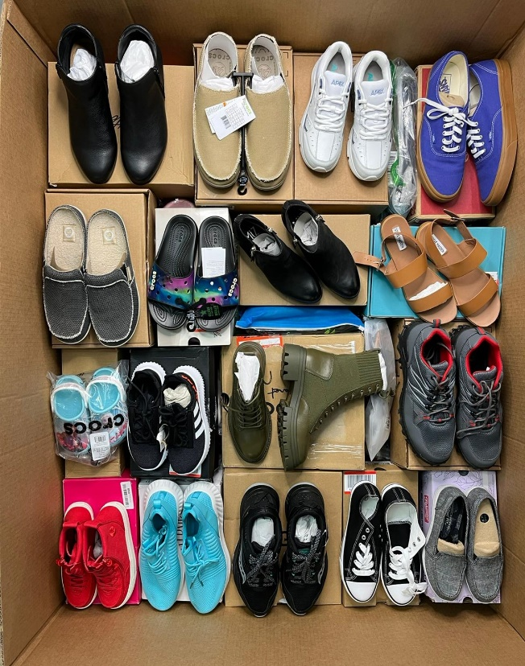
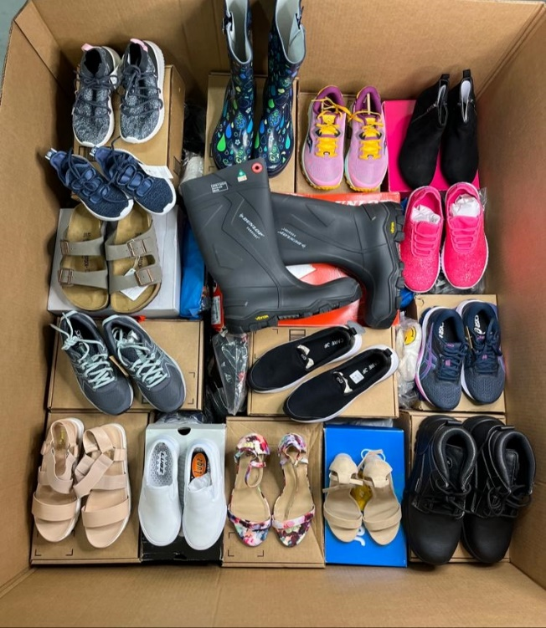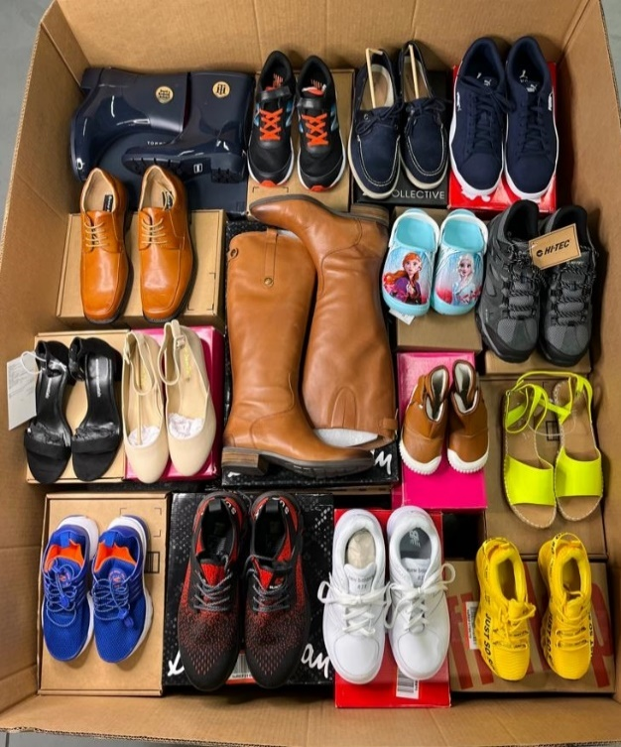

SHELF PULL COSMETICS:
Description: All items are in pull off shelf condition and you should expect a percentage of items to be short on or near expiration dates. Boxes may contain a small percentage of non-cosmetic items, such as fragrances and manicure and pedicure tools. Boxes contain a variety of face, lip, eye and nail cosmetics including foundation, concealer, blush, lipstick, lip gloss, lip liner, eye liner, eye shadow, mascara, nail polish and more .

Brands: Predominant Brands include L'Oréal, Maybelline, Revlon, Covergirl. They can also include brands like Rimmel, Sally Hansen, Kiss, Essie, and Wet N Wild among others.

QUANTITY | DESCRIPTION | PRICE P/P | TOTAL  PRICE
250 | MIXED COSMETICS | $1.68 | $420
500 | MIXED COSMETICS | $1.54 | $770
1000 | MIXED COSMETICS | $1.40 | $1,400

"Keep in mind that we sell liquidation merchandise, so we cannot guarantee that in the boxes we offer you will find all the brands described or the specific quantity of each of them, as well as the specific type of cosmetic they contain"

These descriptions are made in order to provide customers with the most information and accuracy about the conditions of the merchandise we sell.

IF YOU REQUIRE MORE INFORMATION, PLEASE DO NOT HESITATE TO CONTACT US DIRECTLY VIA PHONE, WHATSAPP, EMAIL OR THROUGH OUR SOCIAL MEDIA NETWORKS. WE WILL BE HAPPY TO ASSIST YOU AND WE ARE HERE TO HELP YOU THROUGHOUT THE PURCHASE PROCESS

